**Glomeruli Detection using Transfer Learning Using Mask R-CNN**

**(For Windows users)**

**This model is based on Matterport’s implementation of Mask R-CNN. You can use the files given in thos repository or you can get the complete repository from** [**https://github.com/matterport/Mask_RCNN**](https://github.com/matterport/Mask_RCNN)**.**

**Also, please check the blog at** [**https://gilberttanner.com/blog/train-a-mask-r-cnn-model-with-the-tensorflow-object-detection-api**](https://gilberttanner.com/blog/train-a-mask-r-cnn-model-with-the-tensorflow-object-detection-api)**. The code is inspired from here.**

1. Divide the WSI into tiles using the Segmentation notebooks. There are two notebooks, one is for segmentation with adjacent tiles, and the other is for segmentation for overlapping tiles. Input the size of the tiles that you want in the fourth cell.   
   The stride for over lapping is set to 50%. You can change that by altering the stop size, and the step size in the **range(start, stop[, step])** in the last cell for each resizing block.
2. Download labelme image annotating software from the github link <https://github.com/wkentaro/labelme>
3. Annotate the tiles using polylines and assign them ‘Glomeruli’ class. The annotations for each are stored as json objects with the same name as the tile name.  
   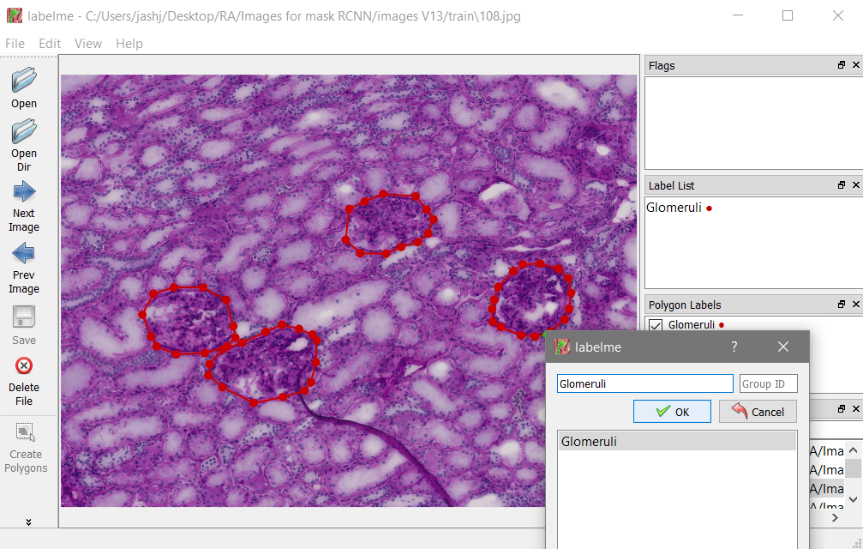  
     
   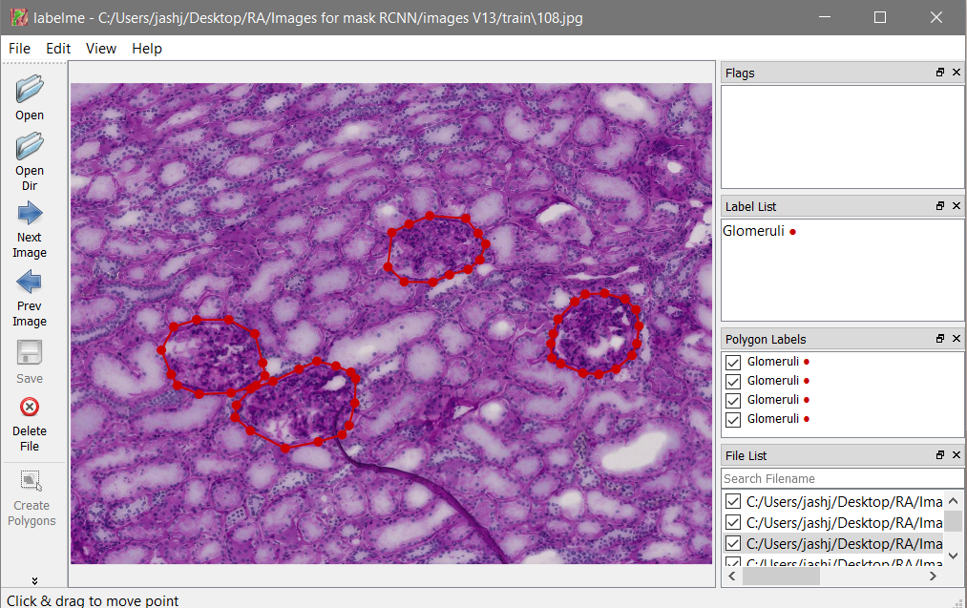
4. There are two jupyter notebooks for Mask R-CNN model training.  
   i. ‘MaskRCNN Glomeruli - Training’: This is for training and testing and calculating MAP.  
   ii. ‘MaskRCNN Glomeruli - Detection and Saving’: This file is for detecting Glomeruli and saving it in the desired format to be used later for stitching to make WSI.  
   In the fourth cell, replace the dimensions with your image dimensions. Currently they are set to 800x600.  
   Also, change the image directories accordingly in cell nos. 4,5,7 in both the files, and in the last cell too in the second file. Also, if you are using pre-trained weights for transfer learning, you can initialize those by making appropriate changes in cell no. 8.  
     
   Imp Note: The output of the Mask R-CNN has dimensions 1024x1024. So the combining code has code for upsizing the stitched image to the original dimensions.
5. To combine the output of Mask R-CNN model, there are two files:  
   i. ‘Combining images’: Use this file if you have used just the normal segmentation file to get adjacent tiles.  
   ii. ‘Combining overlapping tiles’: Use this file if you have used the segmentation with overlap file.  
   In both the files in cell no. 4, input the dimensions of the tiles that you have given for segmentation. It will automatically calculate the number of rows and columns.  
     
   Change the path location for the image and the folder locations. You will have to give three inputs:  
   i. original image  
   ii. Binary masks obtained from the model.  
   iii. Location of masked tiles (This is only required in the file without overlapping).
6. To compute accuracy, you will need to run ‘Accuracy Metrics’ file. The ground truth image is constructed using annotations from QuPath and ImageJ. It was done by 4 four students and the annotations were later plotted on the same image using python. The files for this particular example are provided in this folder.
7. Install tensor and all other dependencies:

pip install pillow

pip install lxml

pip install jupyter

pip install matplotlib

pip install tensorflow==1.15

1. Open Git Bash, check the current directory with “pwd”. If this is where you would like to clone the repository. I created a folder C:/Users/*your-username*/tensorflow. Then use the following to clone on command prompt:

git clone <https://github.com/tensorflow/models> (for tensor flow version 1.15, but other version 1.x are also compatible)

1. For object detection , we need to install several object detection api’s available in tensor flow like:[https://github.com/cocodataset/cocoapi.git](https://github.com/cocodataset/cocoapi.git%20)
   1. For coco api use the following command

git clone [https://github.com/cocodataset/cocoapi.git](https://github.com/cocodataset/cocoapi.git%20)

* 1. Download proto buff from the link <https://github.com/protocolbuffers/protobuf/releases>

protoc-3.11.4-win64.zip

* 1. Place the extracted files from zip folder in ../Tensorflow/models/research/object_detection
  2. Go to ../Tensorflow/models/research and run following command prompt folder

"../Tensorflow/models/research/object_detection/bin/protoc.exe" object_detection/protos/*.proto --python_out=.

1. Open ../Tensorflow/models/research/object_detection/object_detection_tutorial.ipynb and run it to see whether object detection model is working or not
2. Download labeller for glomeruli detection using the link <https://tzutalin.github.io/labelImg/>. It is the GUI version.  
   For python version, you can visit <https://github.com/tzutalin/labelImg>
   1. Open the directory containing cell images using labelImg.  
        
      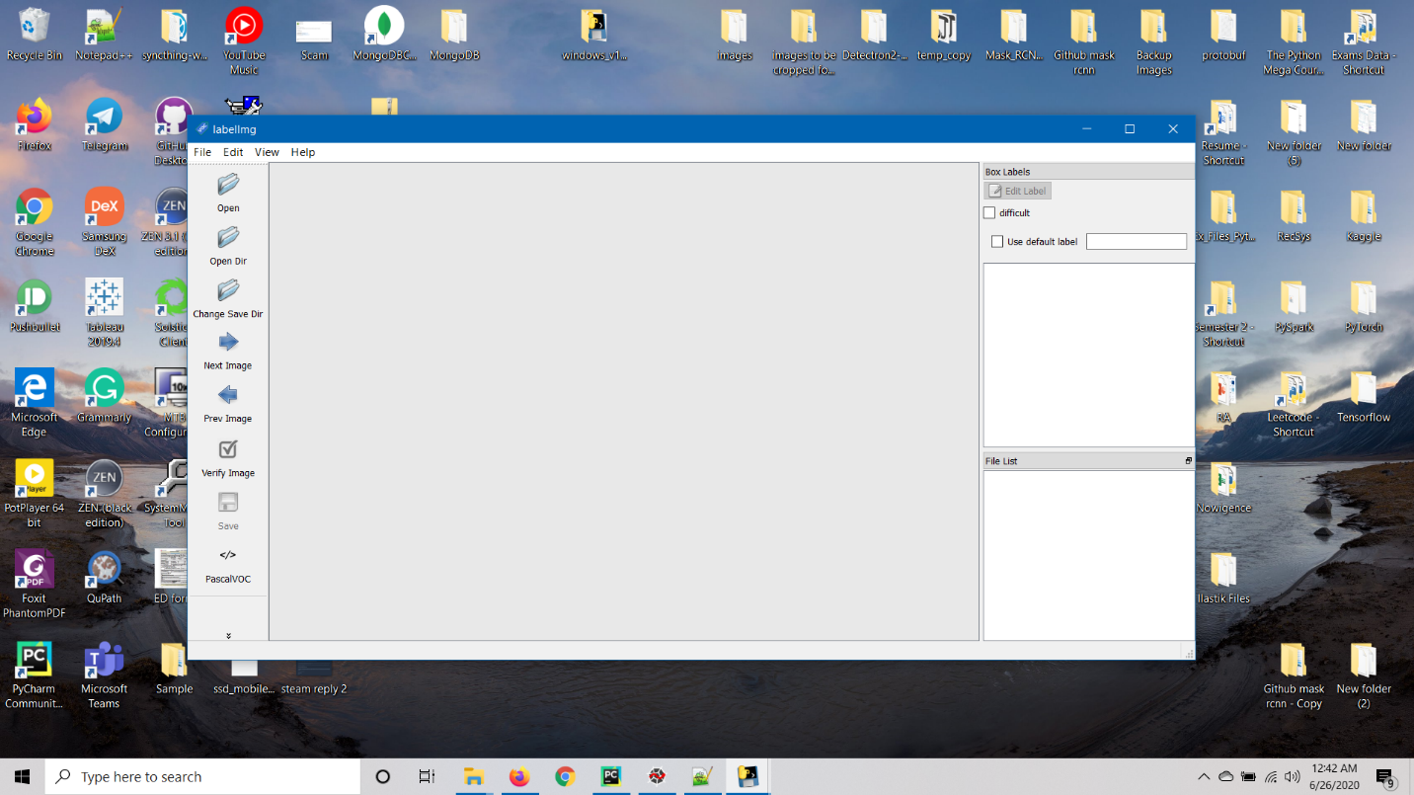
   2. Choose the directory containing the images  
      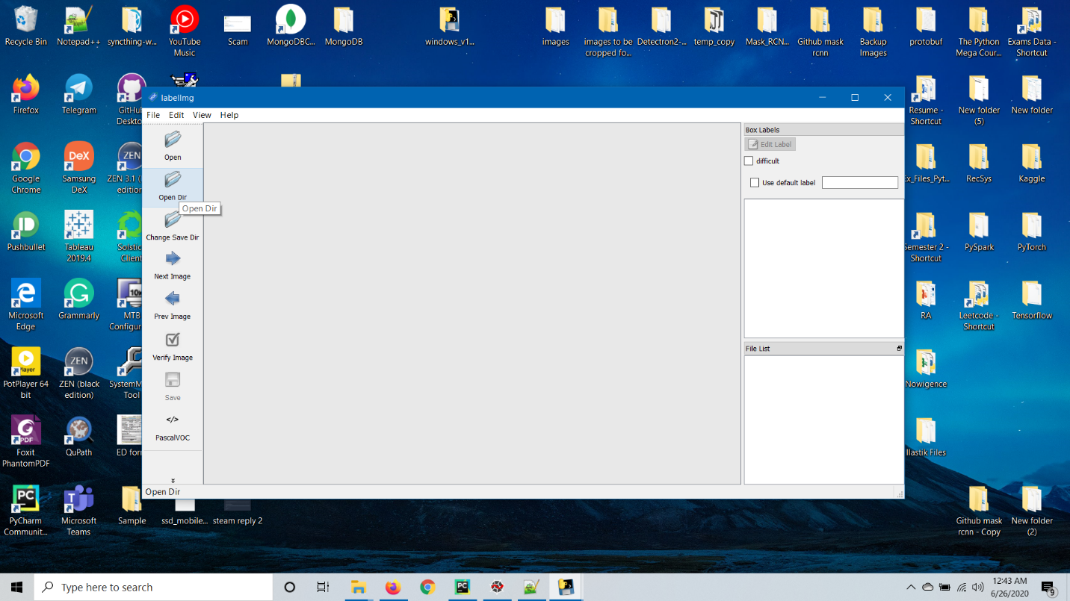  
      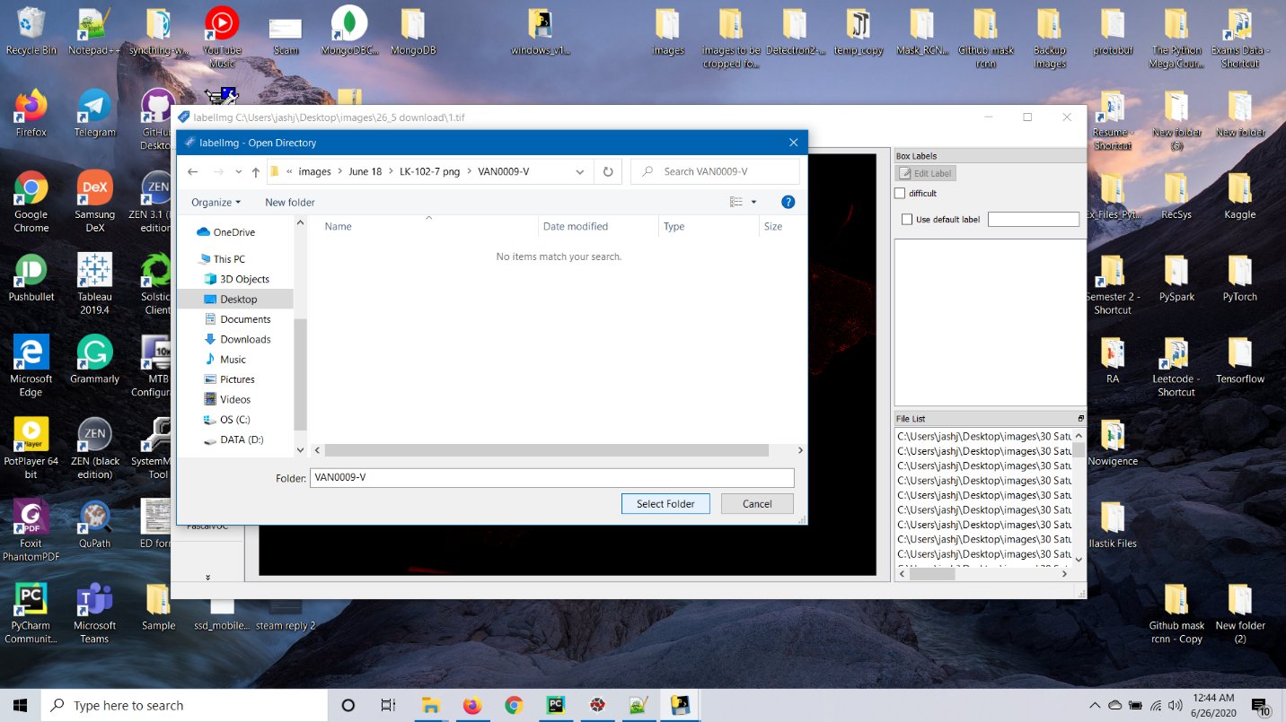
   3. Create RectBox over the glomeruli by dragging over the region.  
      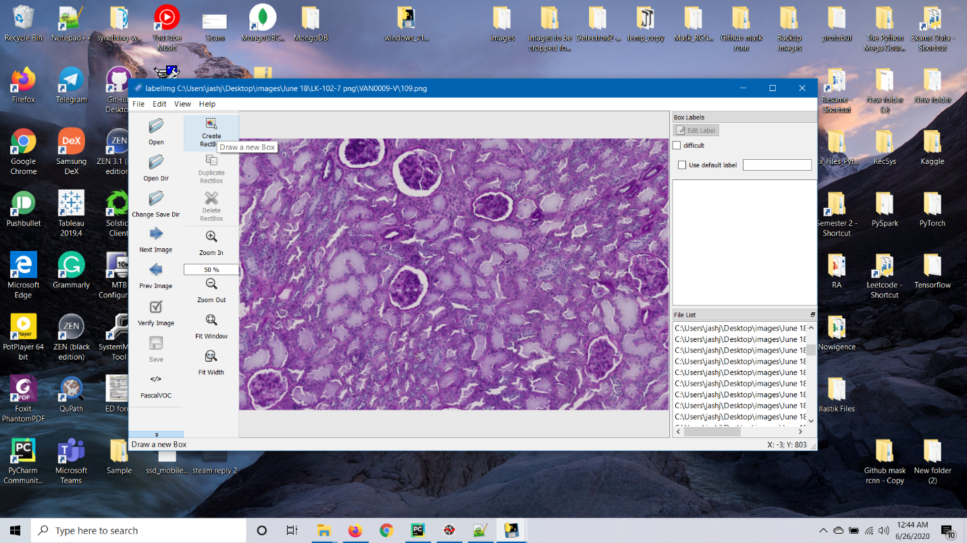  
        
      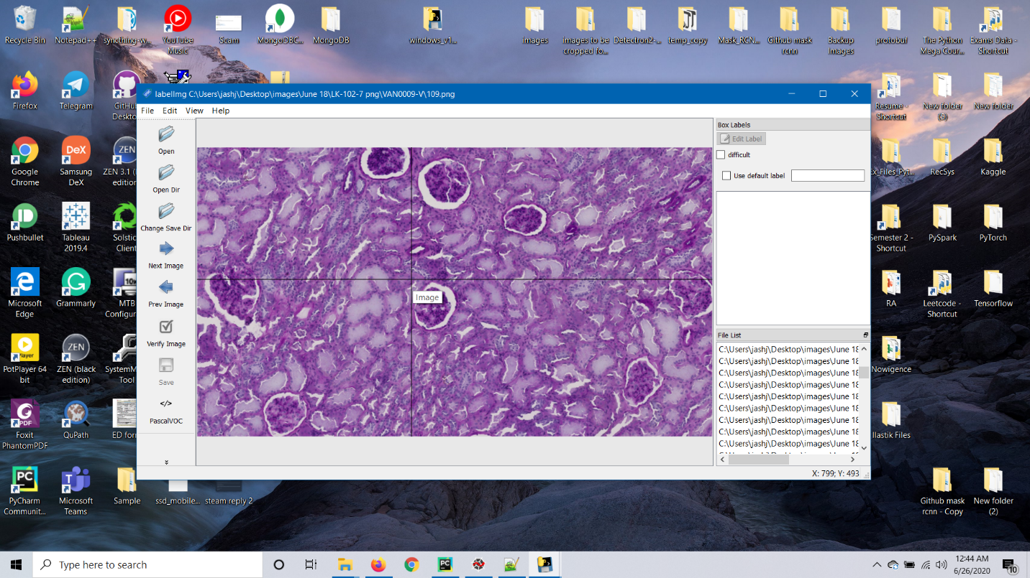
   4. Set the label as ‘Glomeruli’.  
      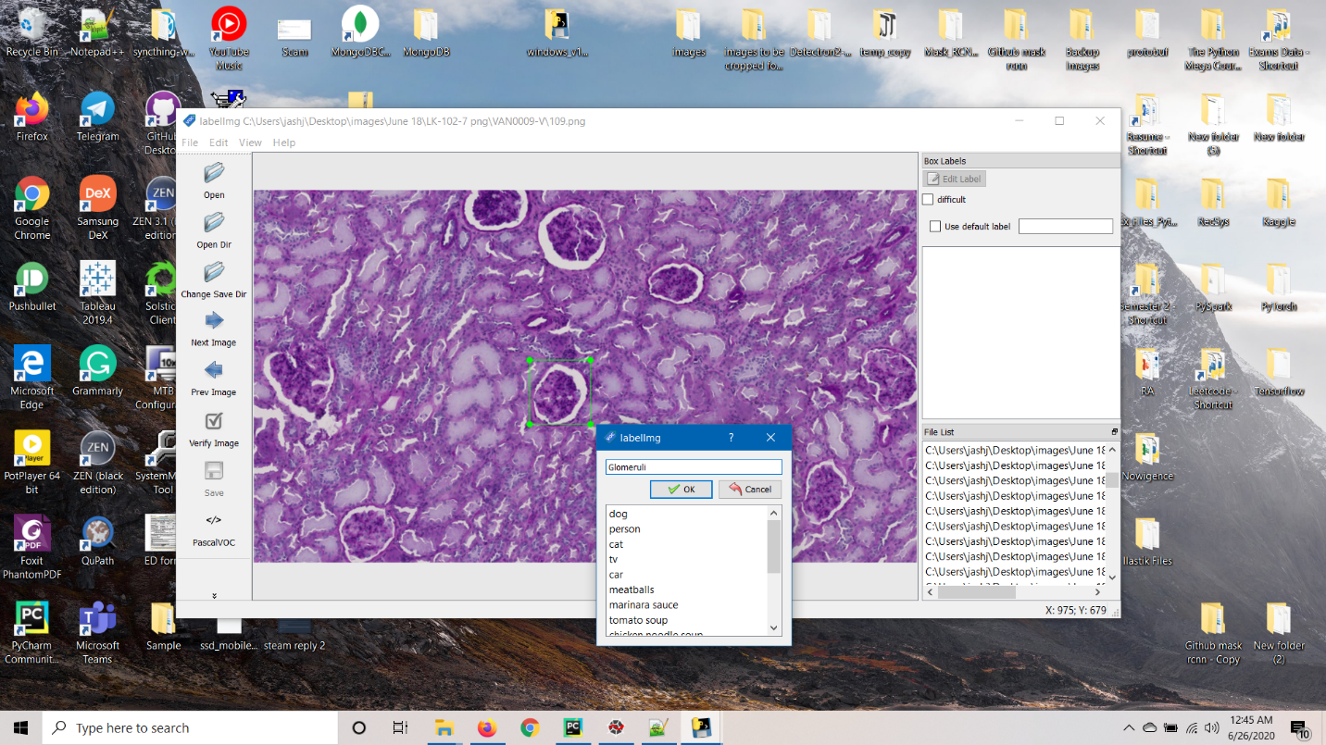  
        
        
      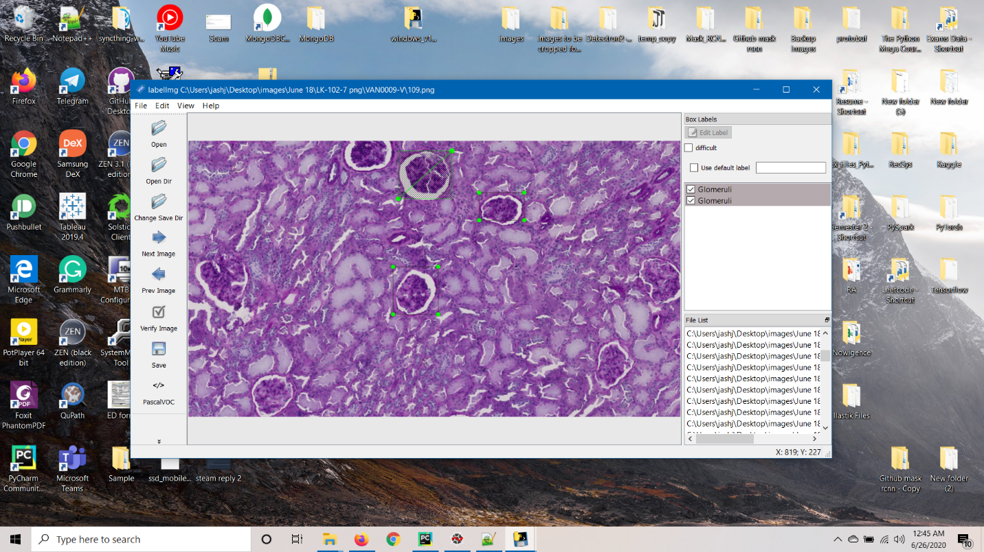
   5. Click on save to set save the annotations in an XML file.  
      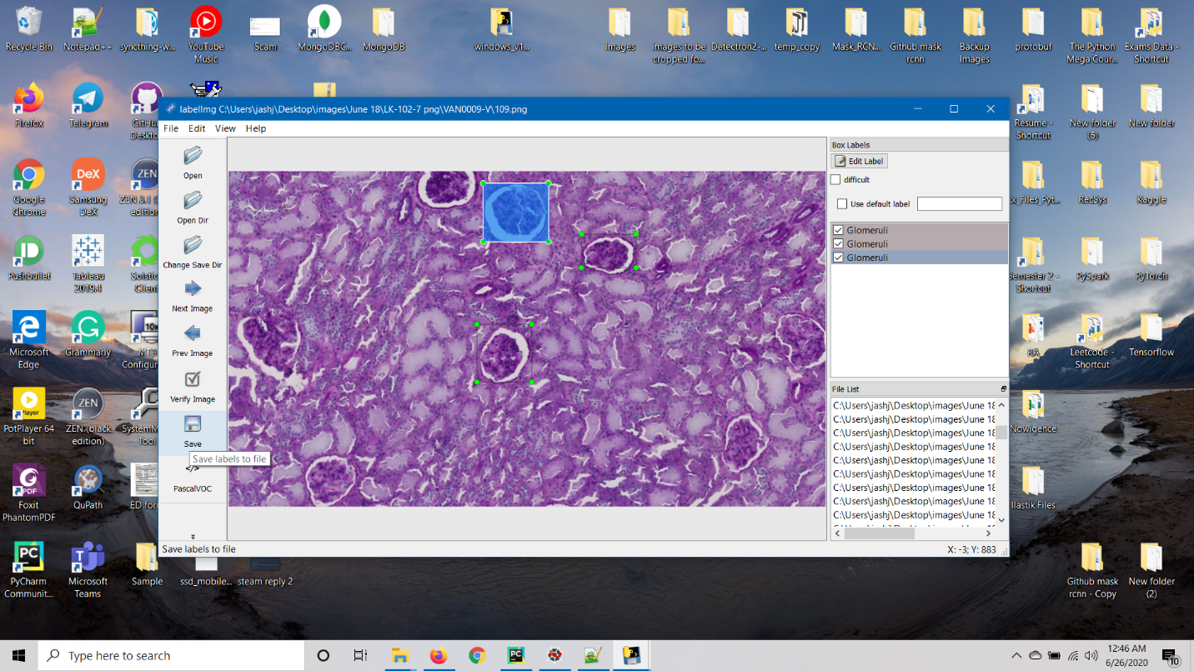  
        
        
        
      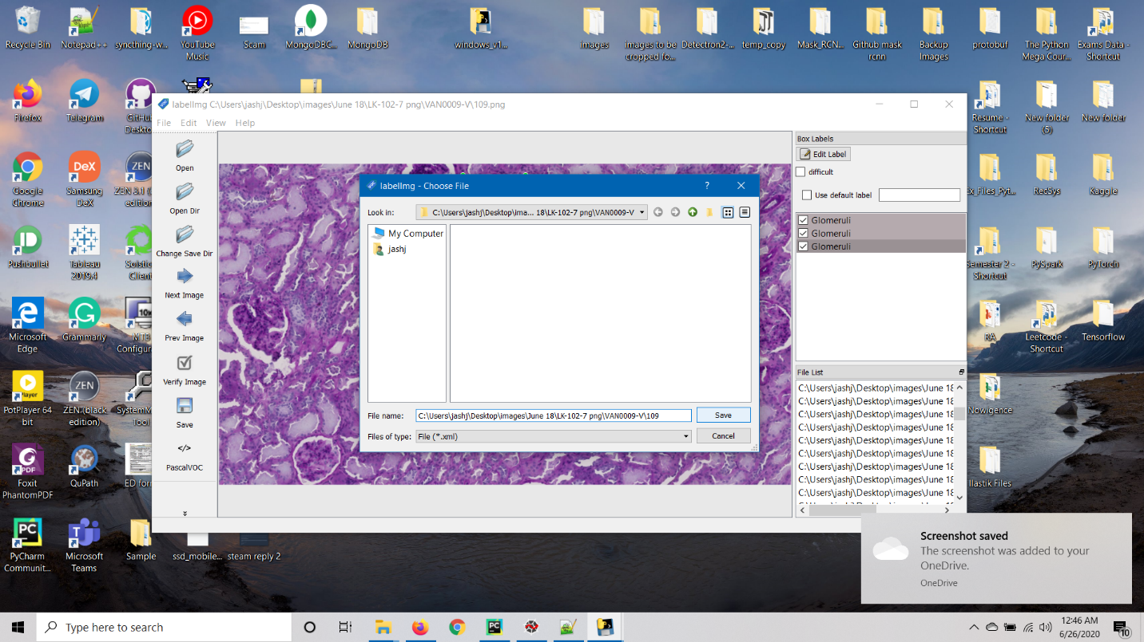
   6. Create a new folder(images) containing test and train images in ../Tensorflow/models/research/object_detection
   7. Save the images in the folder ../Tensorflow/models/research/object_detection/images/train_images  
      ../Tensorflow/models/research/object_detection/images/test_images  
      Keep some of the images (.jpg) on test_images folder as well which you want to test your model
   8. Keep the .jpg in the same folder as .xml file.
3. Run xml_to_csv.py file from the folder ../Tensorflow/models/research/object_detection  
   (file provided. Might need to change the directory in the file)
4. Run generate_tfrecord.py from the folder ../Tensorflow/models/research/object_detection  
   (file provided. Might need to change the directory in the file)  
     
   Command for train files:  
   python generate_tfrecord.py --csv_input=images\train_labels.csv --image_dir=images\train --output_path=train.record

Command for testfiles:  
python generate_tfrecord.py --csv_input=images\test_labels.csv --image_dir=images\test --output_path=test.record

1. Create folder ‘training’ in the object_detection folder with the following two files. Labelmap and [faster_rcnn_inception_v2_pets.config](http://faster_rcnn_inception_v2_pets.config) (Files provided)  
   These files are a custom label map for Glomeruli and a training configuration file. ()  
   Note: Edit the location of the folders in the respective places  
   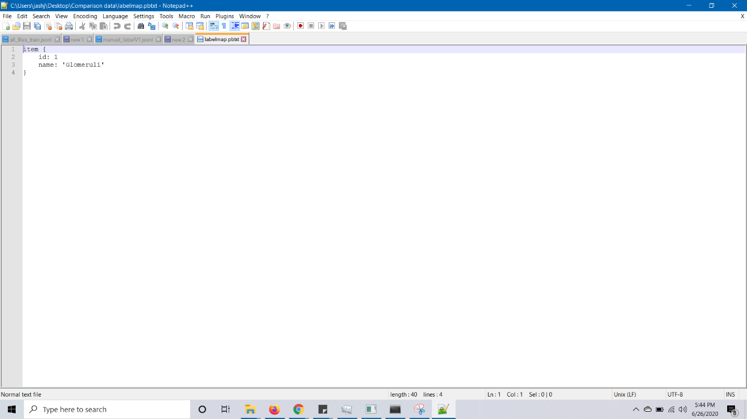
2. From the following link:  
   <https://github.com/tensorflow/models/blob/master/research/object_detection/g3doc/detection_model_zoo.md>  
   download the following file : faster_rcnn_inception_v2_coco.  
   and keep it in the object_detection folder after extracting it.   
   You can choose other weights also. If, you select different weights, then change the names in the following steps accordingly.
3. Extract the folder into ‘../Tensorflow/models/research/object_detection’ folder.  
   Note: After the extraction, the folder named will be faster_rcnn_inception_v2_coco_2018_01_28 (or it can be a later version also).

It has the frozen inference graph and the model files.

1. Edit the [faster_rcnn_inception_v2_pets.config](http://faster_rcnn_inception_v2_pets.config) file accordingly and enter the correct filepaths. Refer to the screenshot below.  
   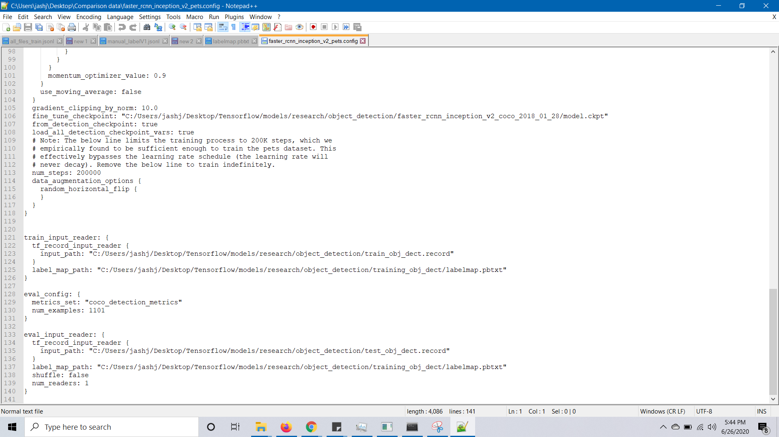
2. Add ‘../Tensorflow/models/research ’ and ‘../Tensorflow/models/research/slim’ folder to PYTHONPATH.
3. From the object_detection folder, run the following command  
   python model_main.py --logtostderr --model_dir=training/ --pipeline_config_path=training/faster_rcnn_inception_v2_pets.config
4. After the training starts, you can see the metrics using tensorboard.  
   From the object_detection folder, run the following command   
   tensorboard --logdir=training

This will open a localhost webpage. If this doesnot happen automatically, run localhost:6006 in Google Chrome.

1. After you are satisfied with the training loss, interrupt the model using Ctrl+C.
2. In the same command window, run the following command:  
     
   python export_inference_graph.py --input_type image_tensor --pipeline_config_path training/faster_rcnn_inception_v2_pets.config --trained_checkpoint_prefix training/model.ckpt-2425 --output_directory inference_graph  
     
   Note: The 2425 refers to the last epoch number before the model was freezed. This can be different in your case. Refer to the below screenshot.  
   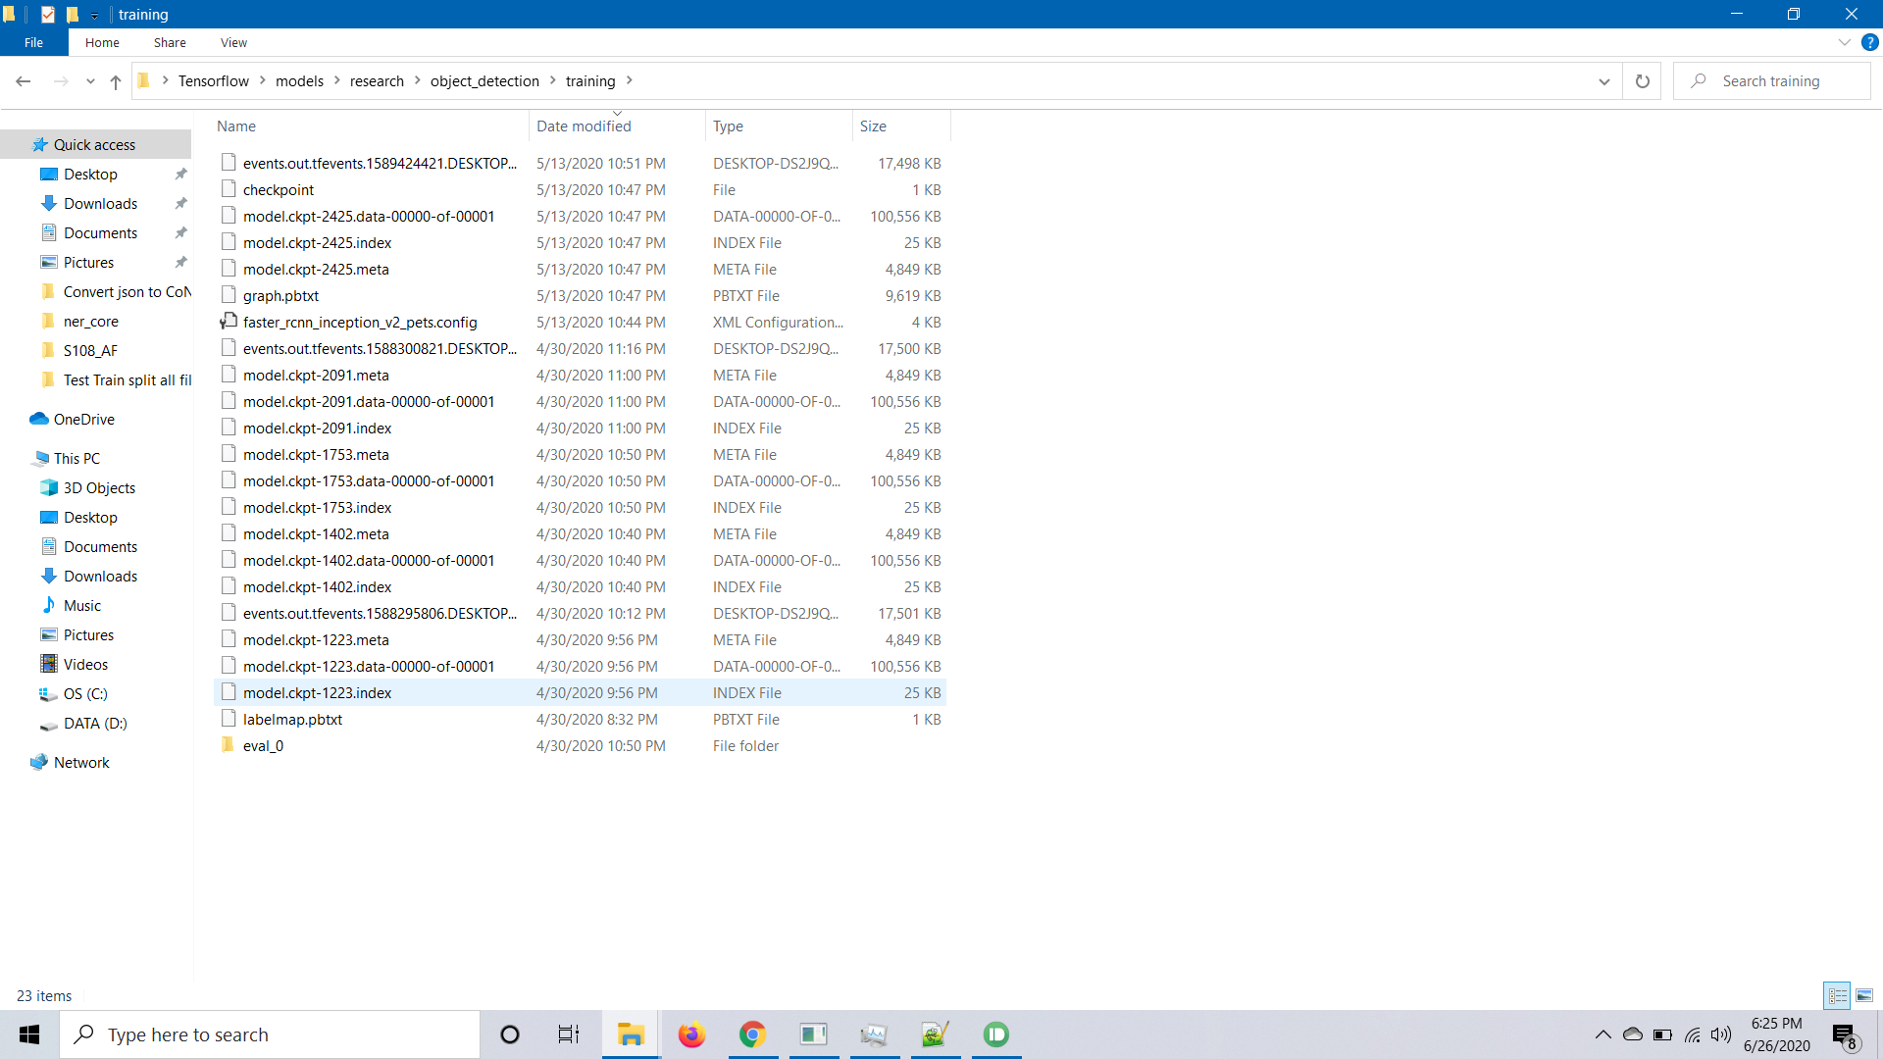
3. Place the jupyter notebook provided in the object detection folder and change the following fields.  
     
   Cell #4  
     
   MODEL_NAME = 'inference_graph’

PATH_TO_FROZEN_GRAPH = MODEL_NAME + '/frozen_inference_graph.pb'

PATH_TO_LABELS = 'training/labelmap.pbtxt'  
  
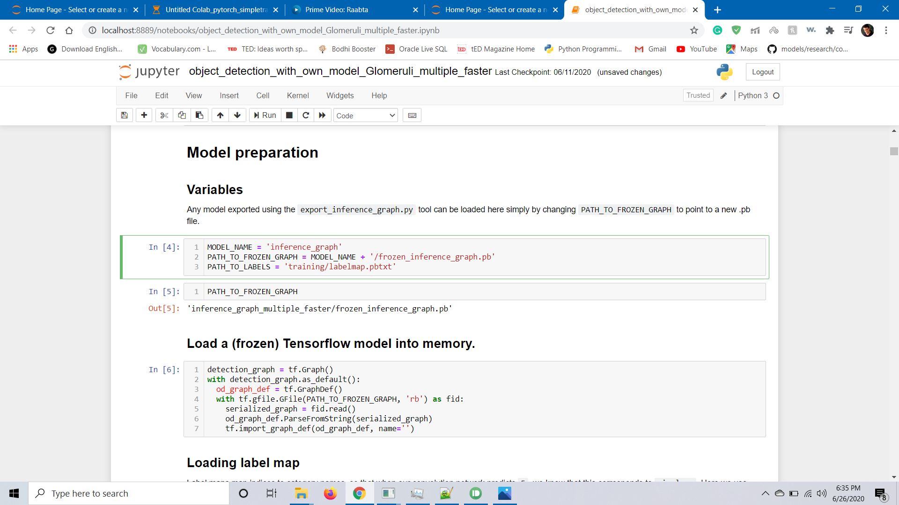  
  
Cell #30, give the path to the image to be tested.

